Technisch Ontwerp



Fontys Hoge School

RB05-4

Inhoud

Basic Flowchart 3

C4-Model 3

Level 1 3

Level 2 4

# Basic Flowchart

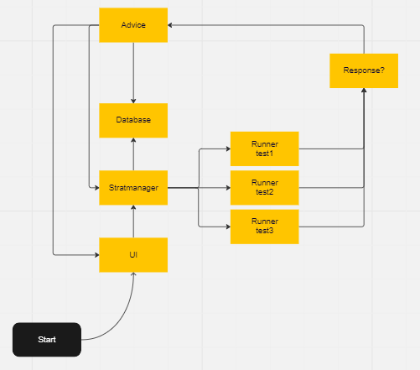

# C4-Model

## Level 1

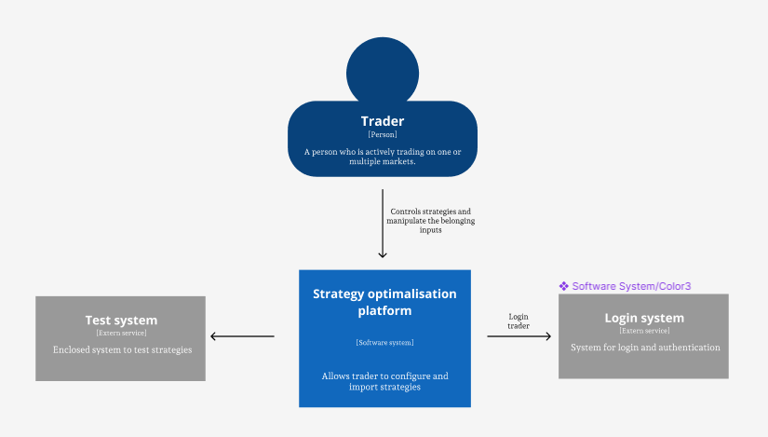

## Level 2

